2023-2024 BPW/OHIO LEGISLATIVE PLATFORM
PREAMBLE:The Alice Paul Equal Rights Amendment shall stand first, foremost and about all other items which may appear on the Legislative Platform of this Federation until equal rights for women and men become guaranteed in the United States Constitution.

THE ALICE PAUL EQUAL
RIGHTS AMENDMENT: Equality of rights under the law shall not be denied or abridge by the United States or by any state on account of sex.

CIVIL RIGHTS: Actively work to pass legislation, which will ensure equal rights and remedies for women in all phases of their lives, including support of affirmative action programs; and eliminate all forms of harassment against individuals, and strengthen and improve voting registration, access, and fair representation.

ECONOMIC EQUITY: Actively work to support equal educational opportunities; equal treatment for women in all areas of employment, including adequate retirement benefits, improved programs for women reentering the workforce, and implementation of equal pay for work of comparable worth.

DEPENDENT CARE: Actively work to strengthen and improve enrichment programs, physical facilities, and funding for affordable quality dependent care of all ages regardless of limitations and abilities.

VICTIM RIGHTS: Actively work to strengthen and enforce legal protection for all individuals who are victims of violent acts including domestic and/or sexual violence (including coercive control); and human trafficking; promote violence prevention programs; support services and facilities for survivors of this violence and the funding thereof; and support legislation, which provides compensatory and punitive damage awards to victims.

HEALTH: Actively work to strengthen and enforce legal protection for full access to all health care services including mental health, Post-Traumatic Stress Disorder (PTSD), reproductive choice, funding for research into and protection for women’s health care and
educational programs concerning women’s health issues.

POLICY: Actively work for the election of and appointment to policy-making positions those who support the BPW Legislative Platform.

ADOPTED MAY 2023

Our Objectives

To Evaluate the standards and Promote the interests of all women in the work place and at home;

To Bring about a spirit of cooperation among all women of Ohio;

To Extend opportunities to all women of Ohio through advocacy, education and information.

BPW/Ohio Mission Statement

The mission of this federation shall be to achieve equity for all women in the workplace and to empower all women through advocacy, education and information.

Contact and Membership Information

More information can be found on the state website at www.bpwohio.org.

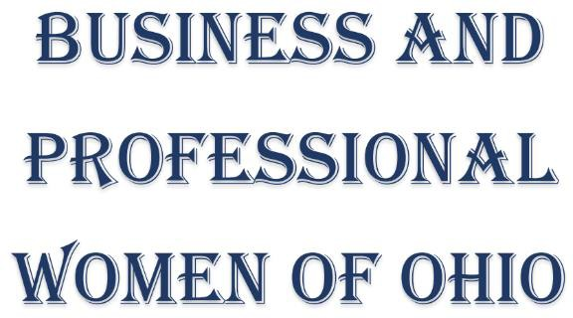

Leading Advocate for Women for More Than 100 Years

Member Benefits Is BPW for me?

- Advocacy – Ohio BPW keeps pace with national and state issues that are crucial to women.
- Education/Career Enhancement – Signature Programming, BPW Individual Development and Young Careerist are specifically designed to provide personal and professional development, growth and opportunities.
- Friendships – Lasting bonds are formed by participating in BPW local, regional and state meetings and events as well as the BPW Signature Programs.

- Helping Others – Through monetary and time donations along with utilizing your mentoring and networking skills you not only contribute to someone else’s life development but your own as well.
- Information – BPW strives to keep up to date relevant information about topics essential for women in front of our membership. Information is always a click, text or phone call away.
- Leadership – Your career will get a boost by learning new leadership skills. Members enjoy opportunities to utilize and/or develop their shills in a safe environment participating in local, regional and state community events. Mentors are there to assist as you expand your leadership base on your way to becoming a recognized leader in your community.
- Visibility – There are opportunities to shine and promote yourself with your involvement in BPW on all levels at meetings and events. Contributing articles to the state OBW and local news letters will gain recognition for yourself and your business.

Our Vision
To be the leading advocate for women’s issues. We are a nonsectarian, nonpartisan, and non profit group of women empowering women personally, professionally, and politically.

Why BPW? What Do We Do?

Advocate
- Victims of domestic violence, rape and human trafficking
- Pay equality and equity in the workplace for all women and men
- Ratification of the ERA
- Legislation that affects all women locally, state wide and nationally

Support
- Women in our armed services and those returning home to reenter the workforce
- Buckeye Girls State where young women learn and understand governance

Awards, Scholarships, Grants and Programs
- Joyce M. Davis Distinguished Member Award given each year for an outstanding BPW member
- Women’s Retirement Foundation Yearly Nursing Scholarship
- Women’s Retirement Foundation Grant available to support a non-profit, low income/subsidized senior housing facility in each region.

Signature Development Programs
- The Individual Development program has provided numbers of women with leadership, negotiation and professional skills necessary to reach their full potential
- The Young Careerist program gives a leg up to young women new to the workforce and full of potential.
- Do you like helping others succeed?
- Do you enjoy lifelong learning?

- Do you enjoy practicing . . .
advocacy? friendship? networking? mentoring?
personal development?

- Do you think and act . . .
locally? regionally? statewide?
- Do you take professional responsibility on local and state levels of our . . .
economy? politics? society?
- Do you care about issues that affect . . .
women? family?
- Do you agree with the BPW Legislative Platform?
- Did you answer yes to one or more of the above?
Then you are a potential BPW member.

Come join us!

BPW/Ohio Website: www.BPWOhio.org
Facebook: www.facebook.com/BPWOhio

